Test Case: tc002_SPX_Dev5_Validar_Campos_Captura_Cotizaciones
Step 1 - Enter username and password and click to button Enter : Credentials Entered
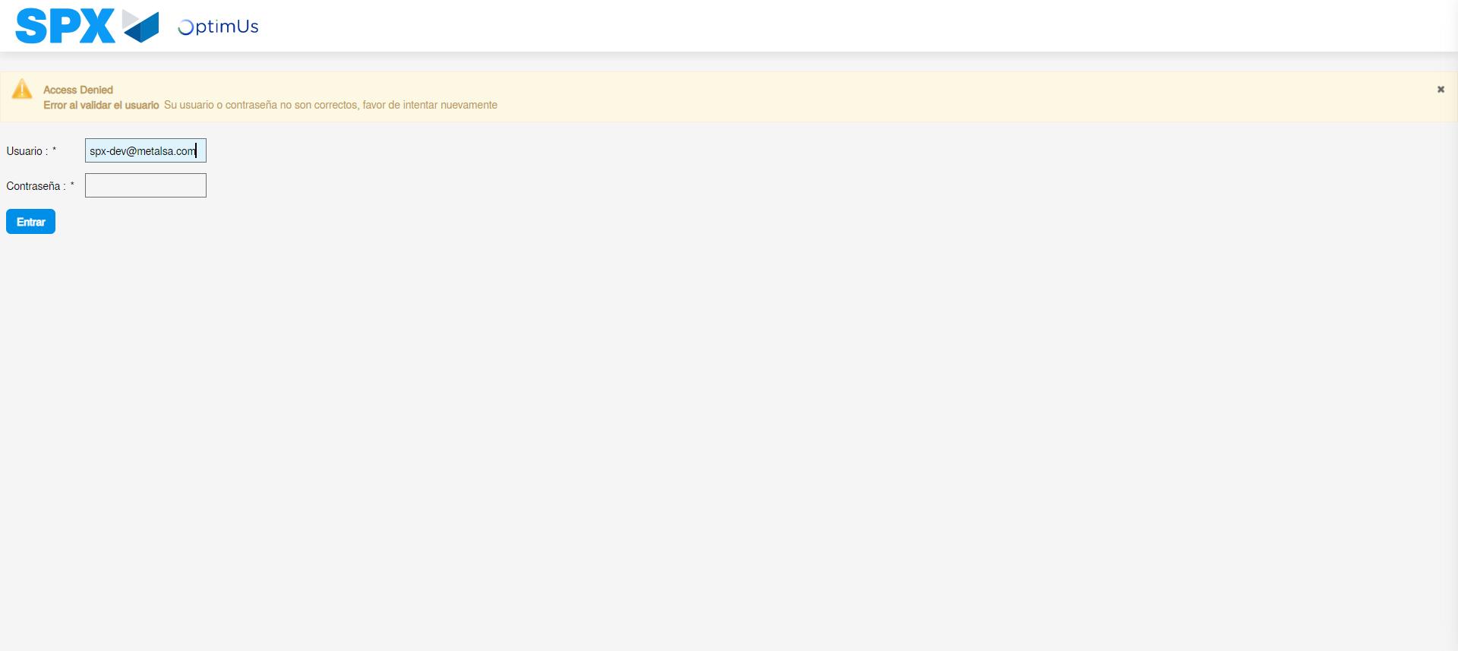Image file-name: QC_Testing-tc002_SPX_Dev5_Validar_Campos_Captura_Cotizaciones-may. 16 2024, 03 24 07 p. m.

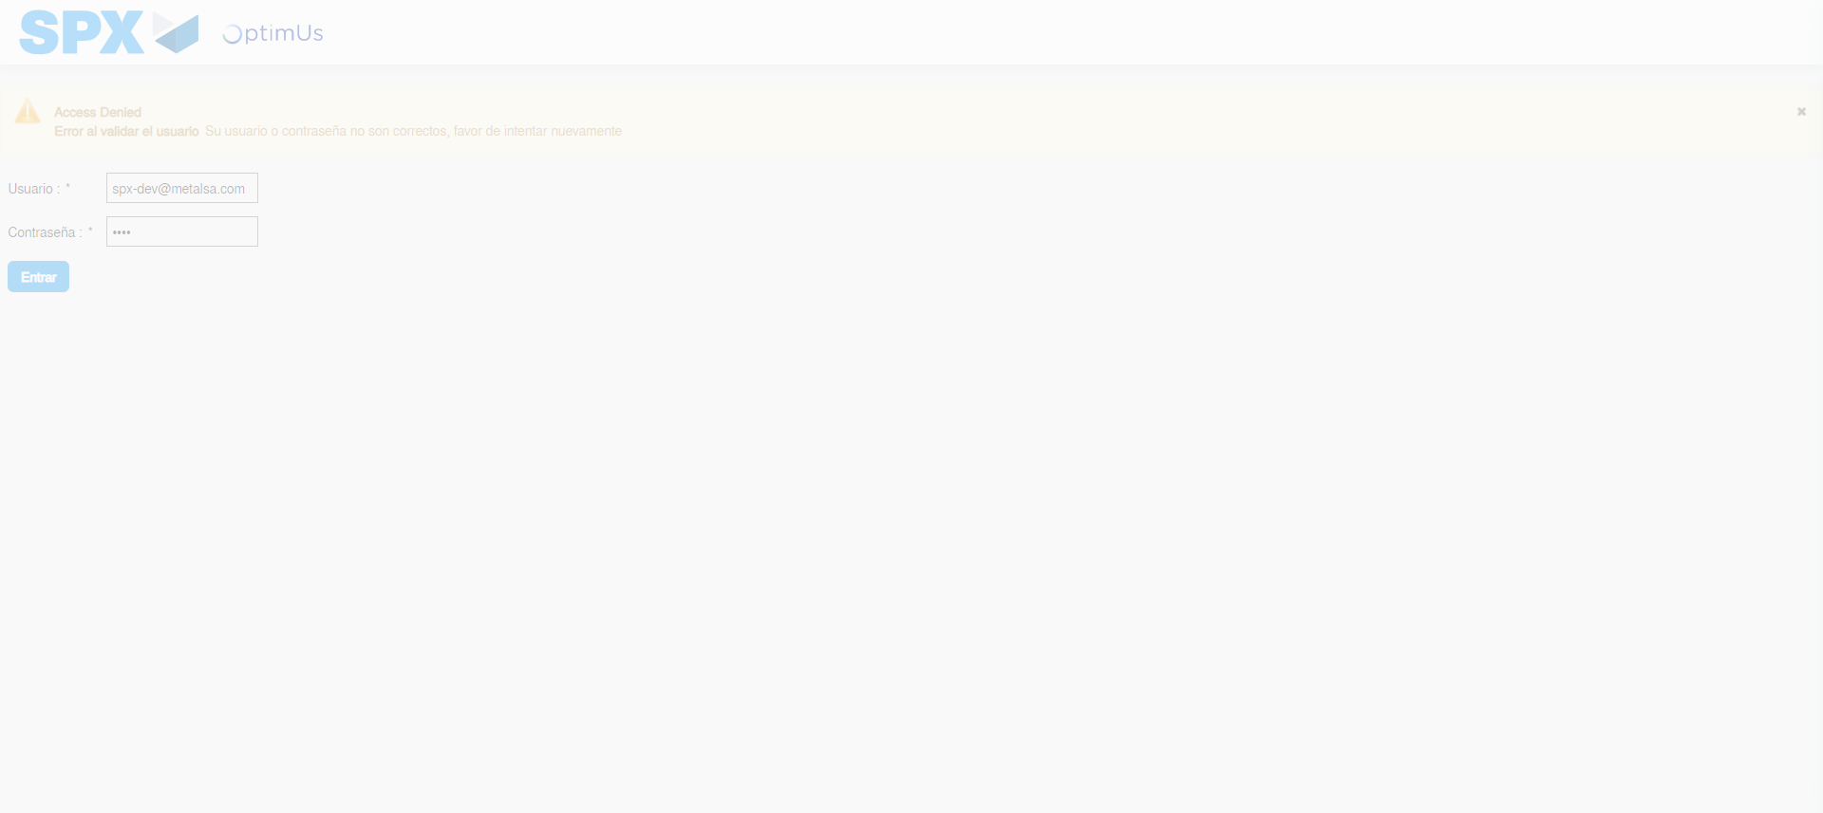Image file-name: QC_Testing-tc002_SPX_Dev5_Validar_Campos_Captura_Cotizaciones-may. 16 2024, 03 24 08 p. m.

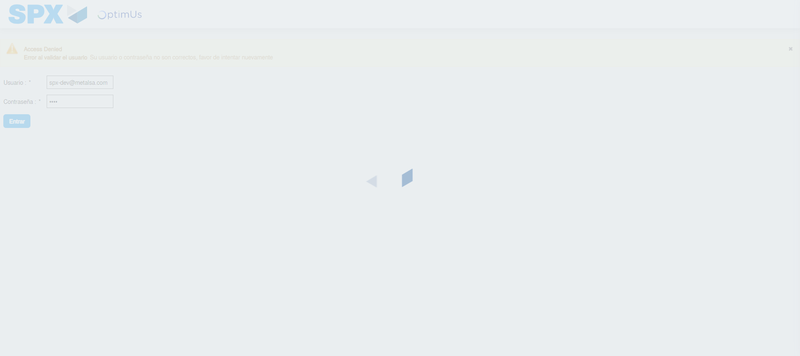Image file-name: QC_Testing-tc002_SPX_Dev5_Validar_Campos_Captura_Cotizaciones-may. 16 2024, 03 24 09 p. m.

Step 2 - Select to UEN and Access to Captura de Cotizaciones: UEN Correctly selected and Correct access
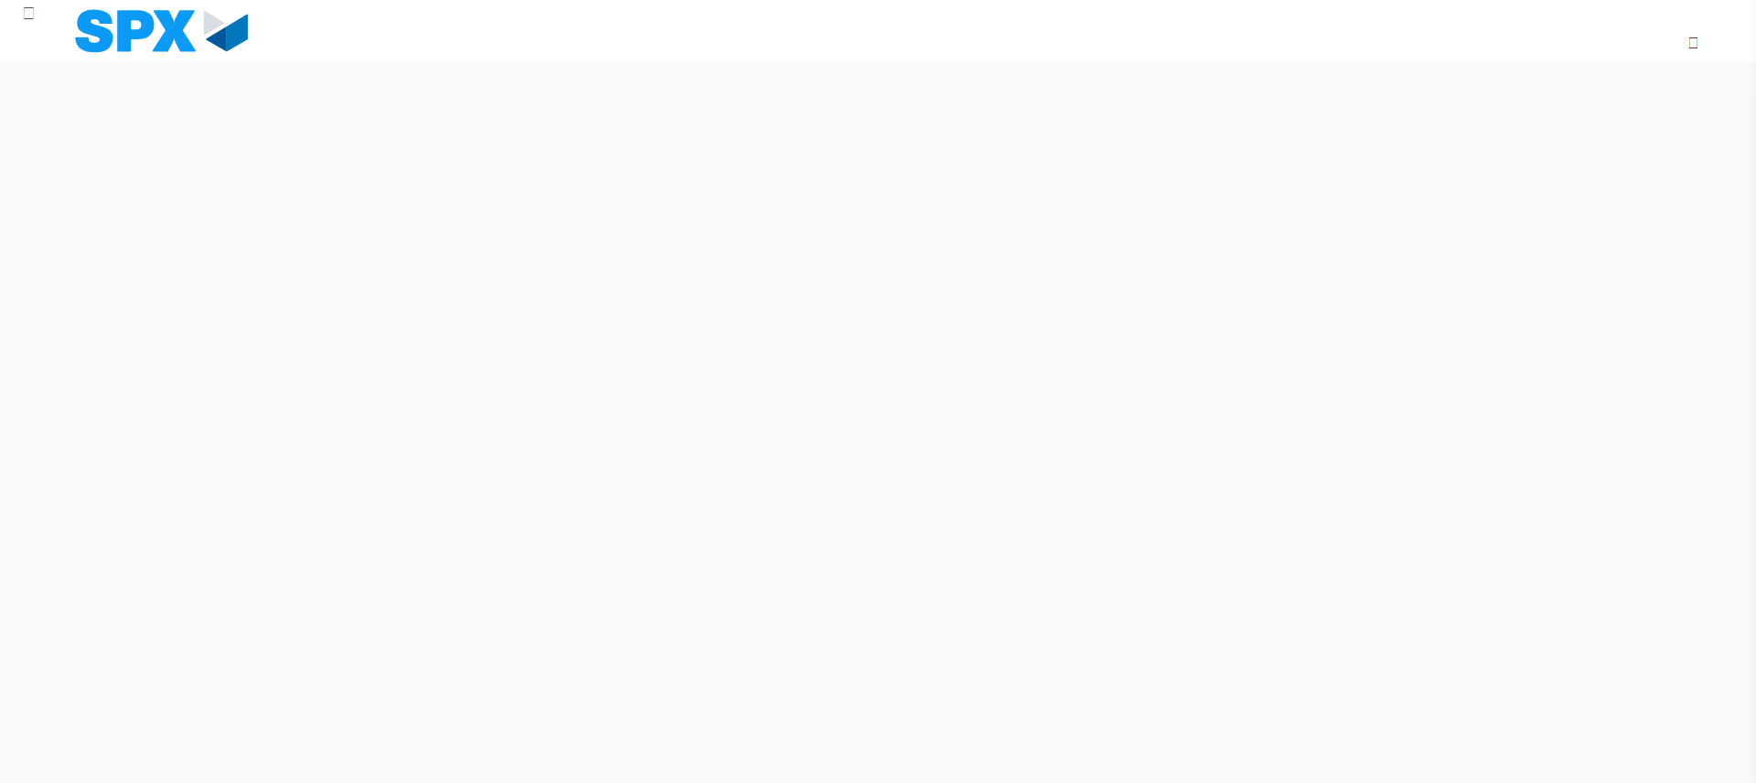Image file-name: QC_Testing-tc002_SPX_Dev5_Validar_Campos_Captura_Cotizaciones-may. 16 2024, 03 24 17 p. m.

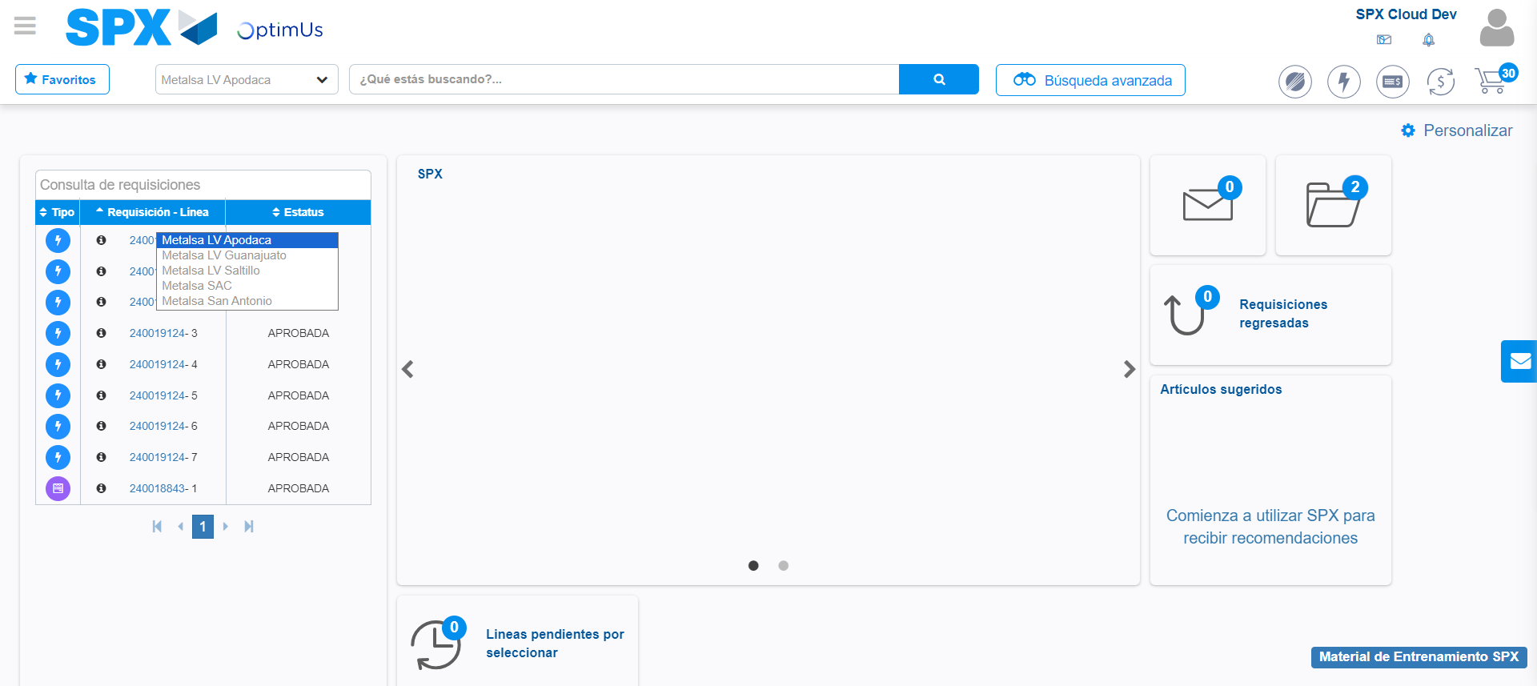Image file-name: QC_Testing-tc002_SPX_Dev5_Validar_Campos_Captura_Cotizaciones-may. 16 2024, 03 24 18 p. m.

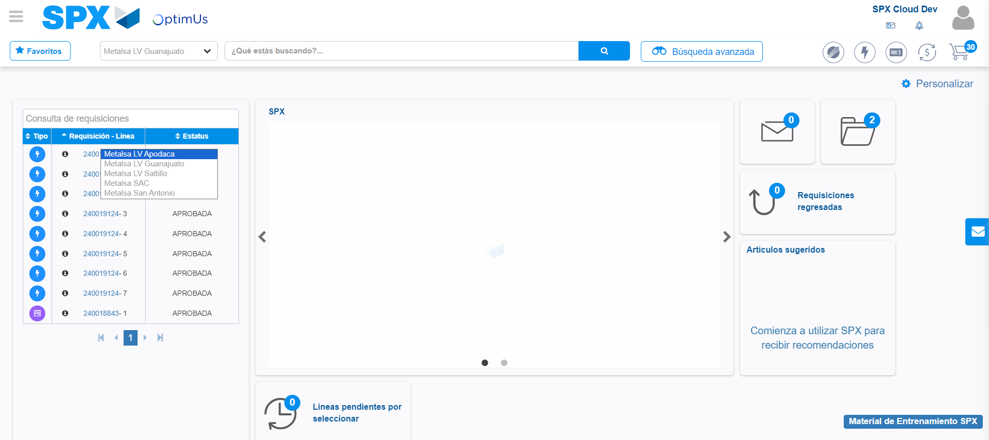Image file-name: QC_Testing-tc002_SPX_Dev5_Validar_Campos_Captura_Cotizaciones-may. 16 2024, 03 24 19 p. m.

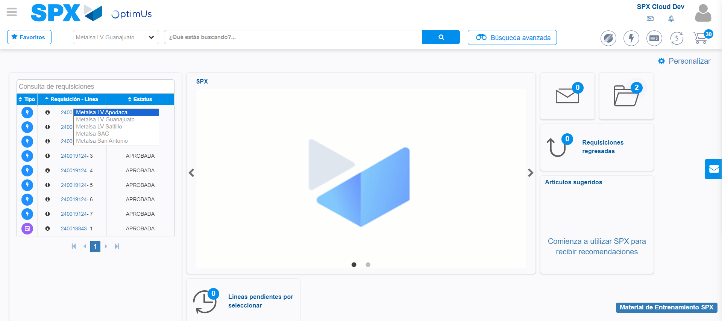Image file-name: QC_Testing-tc002_SPX_Dev5_Validar_Campos_Captura_Cotizaciones-may. 16 2024, 03 24 20 p. m.

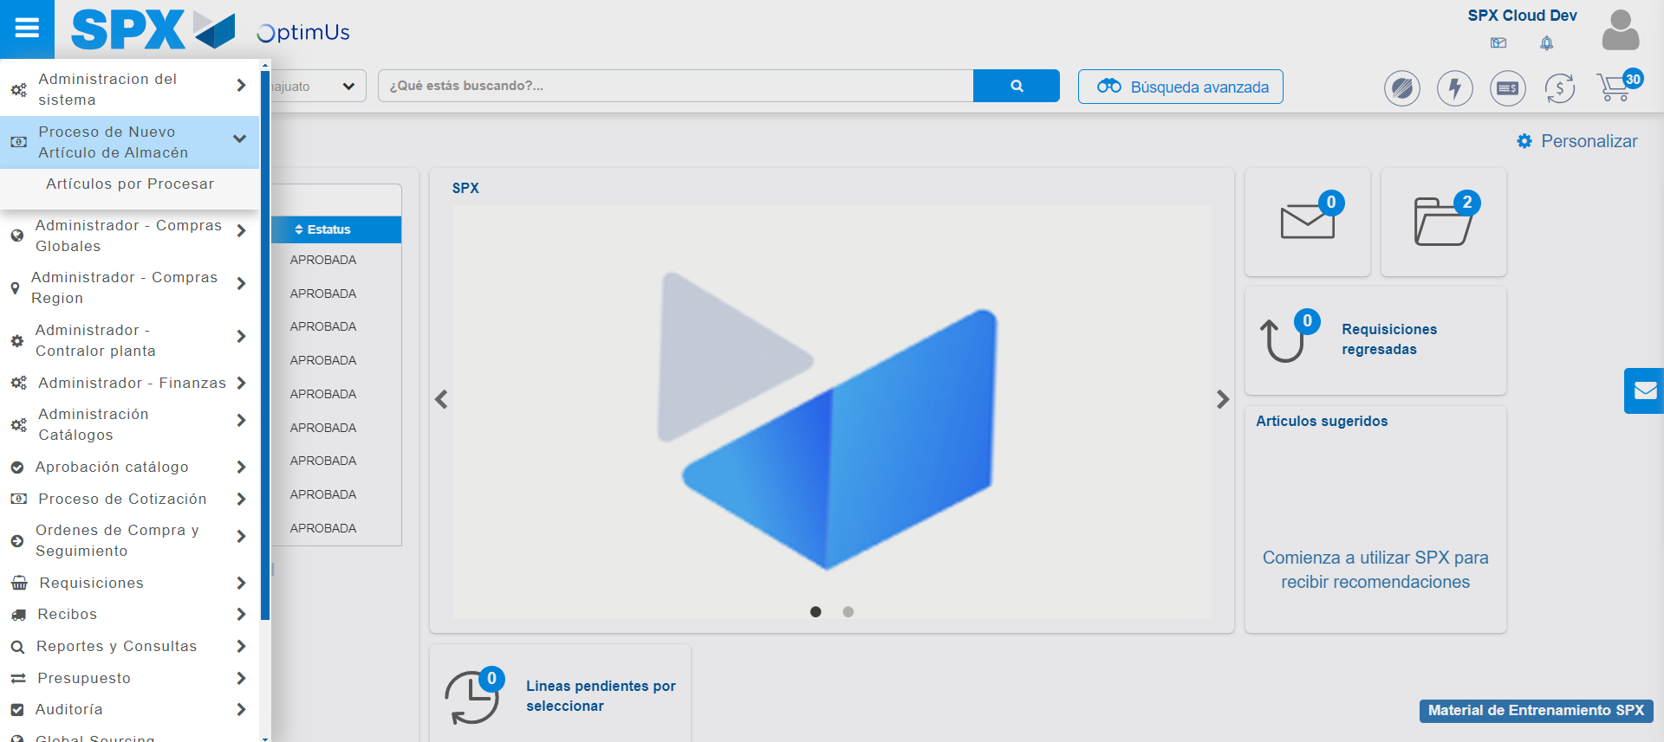Image file-name: QC_Testing-tc002_SPX_Dev5_Validar_Campos_Captura_Cotizaciones-may. 16 2024, 03 24 21 p. m.

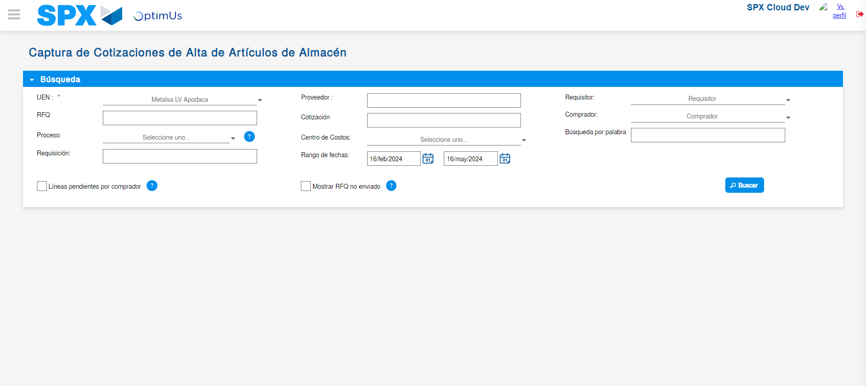Image file-name: QC_Testing-tc002_SPX_Dev5_Validar_Campos_Captura_Cotizaciones-may. 16 2024, 03 24 27 p. m.

Step 3 - Validate search fields: Validated fields
Image file-name: QC_Testing-tc002_SPX_Dev5_Validar_Campos_Captura_Cotizaciones-may. 16 2024, 03 24 27 p. m.

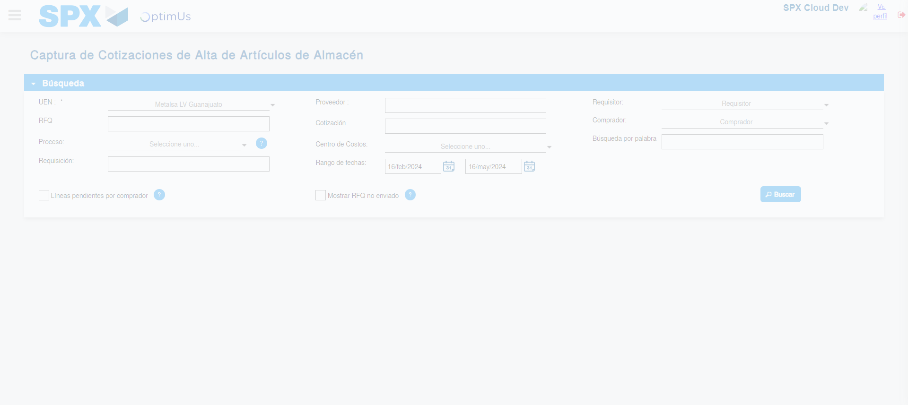Image file-name: QC_Testing-tc002_SPX_Dev5_Validar_Campos_Captura_Cotizaciones-may. 16 2024, 03 24 28 p. m.

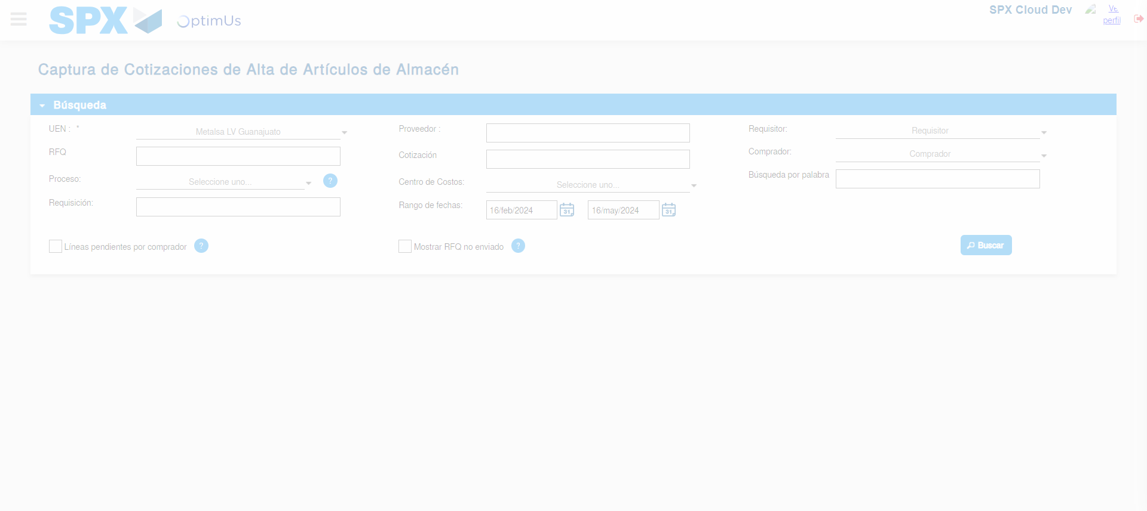Image file-name: QC_Testing-tc002_SPX_Dev5_Validar_Campos_Captura_Cotizaciones-may. 16 2024, 03 24 31 p. m.

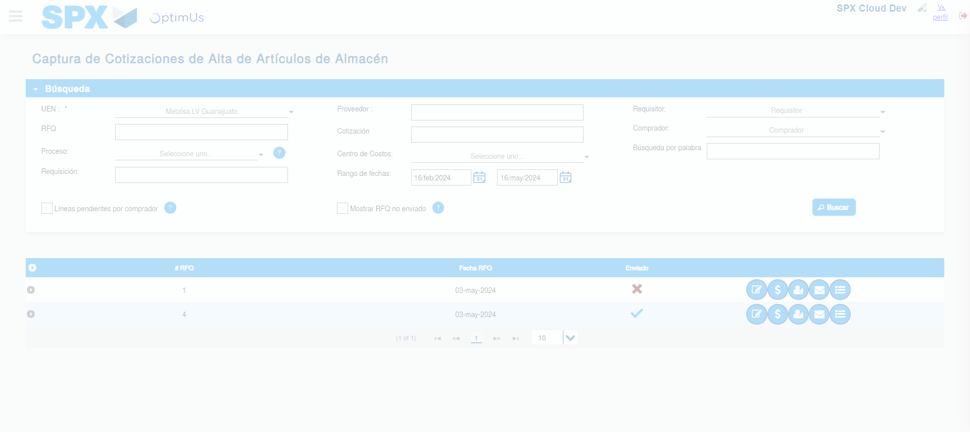Image file-name: QC_Testing-tc002_SPX_Dev5_Validar_Campos_Captura_Cotizaciones-may. 16 2024, 03 24 35 p. m.

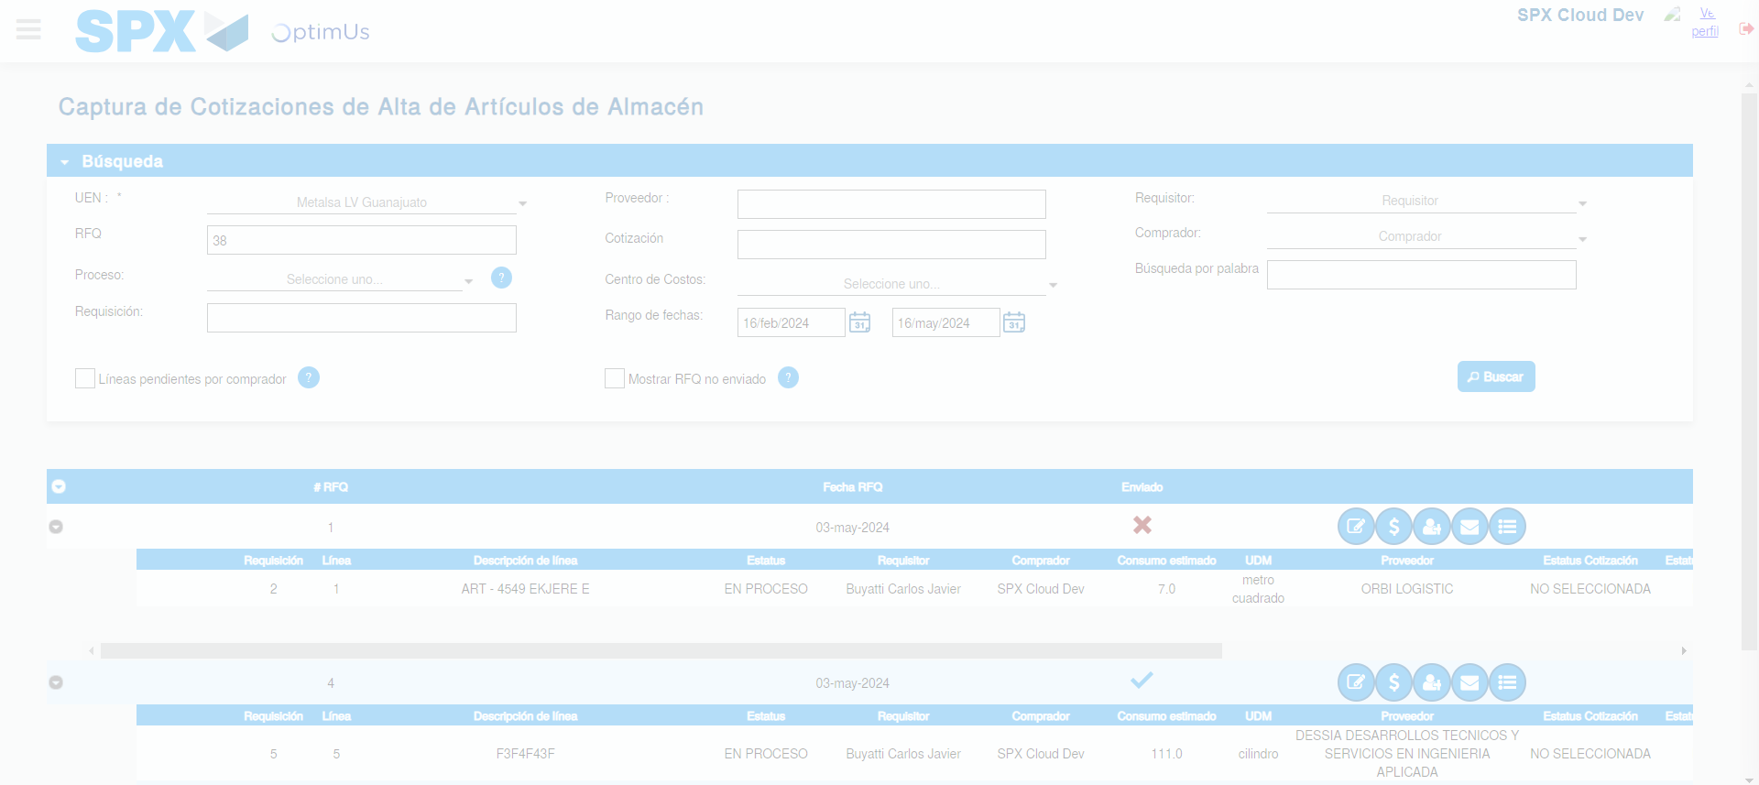Image file-name: QC_Testing-tc002_SPX_Dev5_Validar_Campos_Captura_Cotizaciones-may. 16 2024, 03 24 36 p. m.

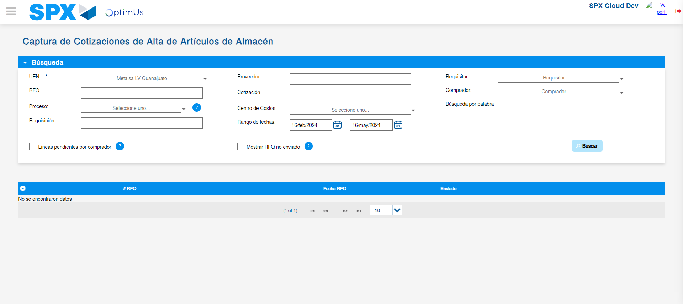Image file-name: QC_Testing-tc002_SPX_Dev5_Validar_Campos_Captura_Cotizaciones-may. 16 2024, 03 24 39 p. m.

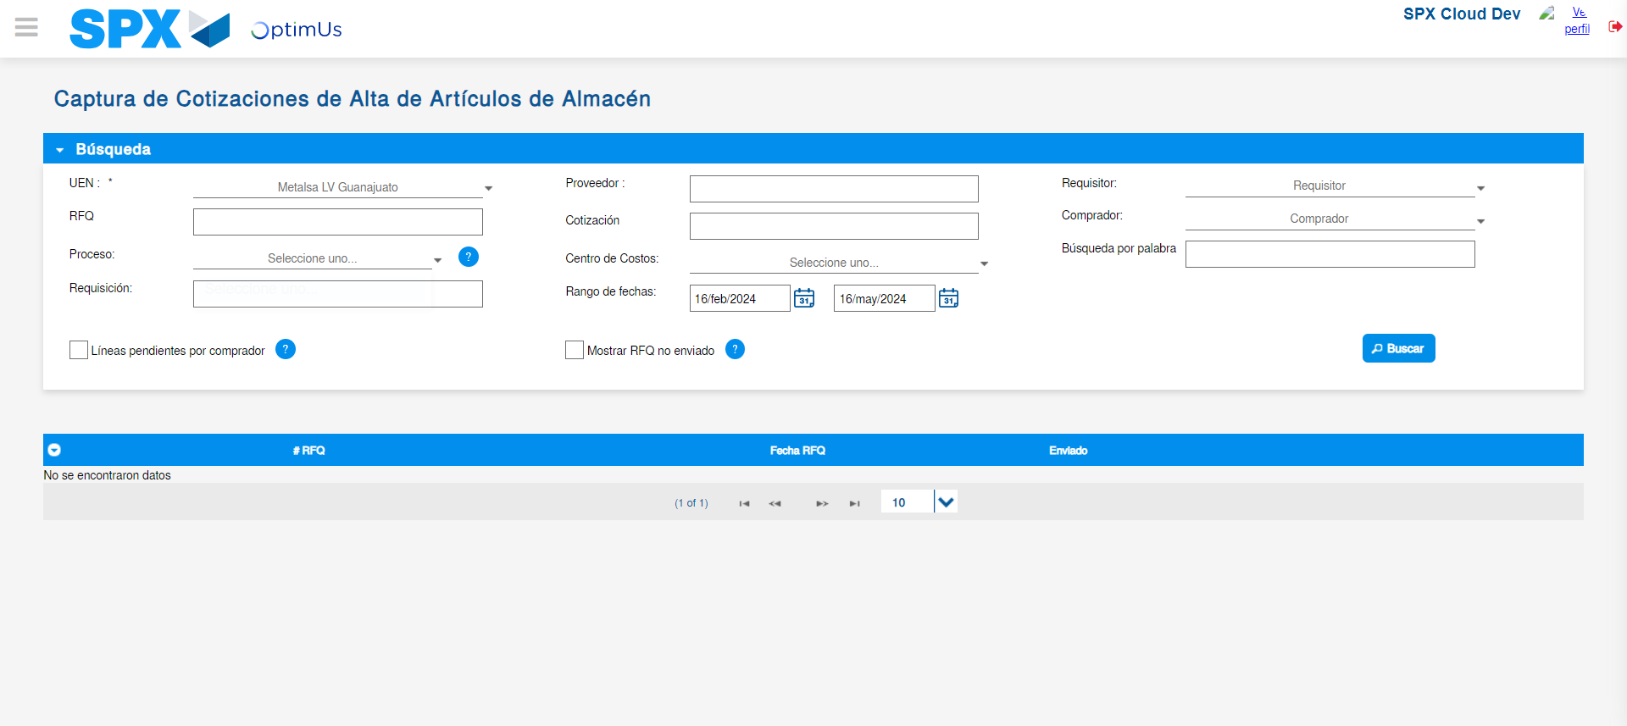Image file-name: QC_Testing-tc002_SPX_Dev5_Validar_Campos_Captura_Cotizaciones-may. 16 2024, 03 24 43 p. m.

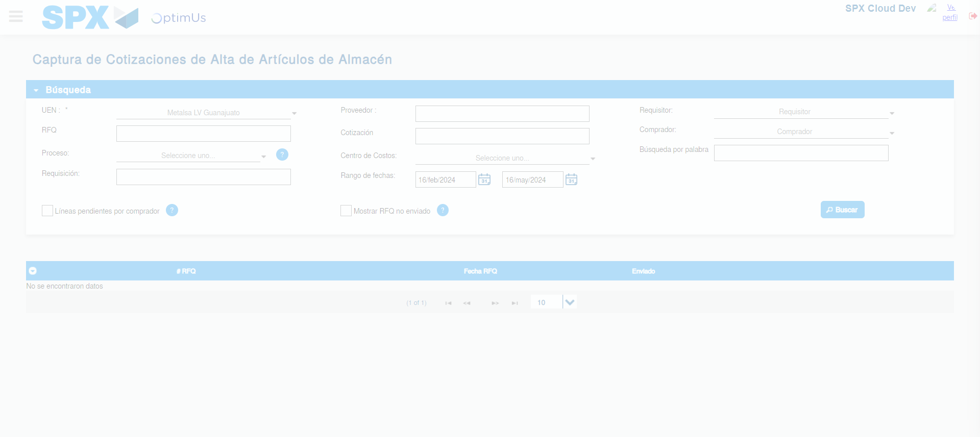Image file-name: QC_Testing-tc002_SPX_Dev5_Validar_Campos_Captura_Cotizaciones-may. 16 2024, 03 24 53 p. m.

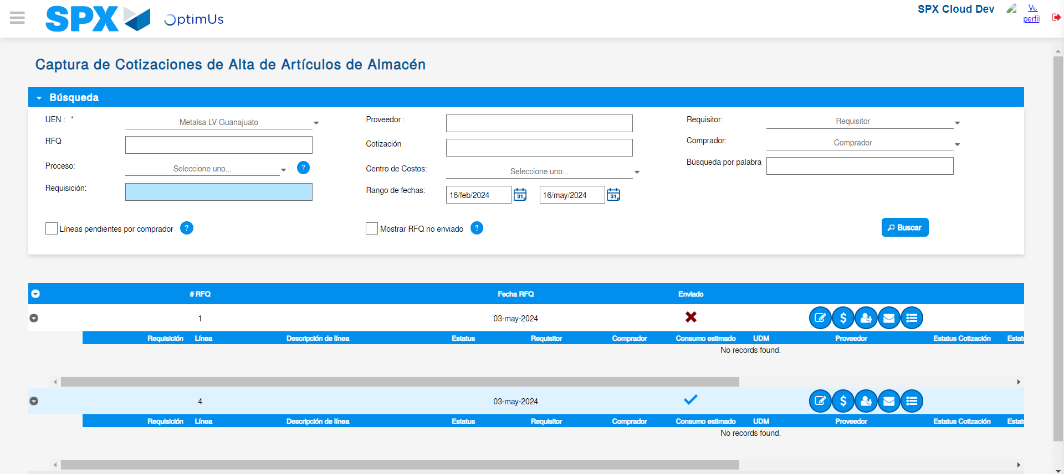Image file-name: QC_Testing-tc002_SPX_Dev5_Validar_Campos_Captura_Cotizaciones-may. 16 2024, 03 24 57 p. m.

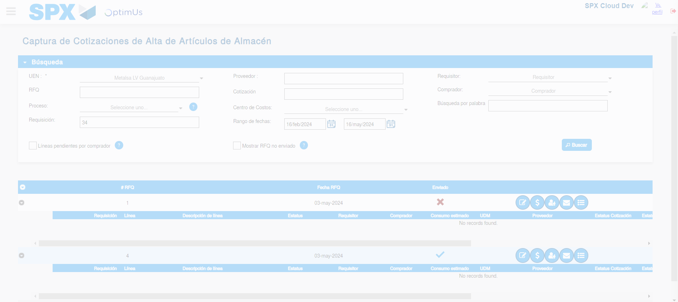Image file-name: QC_Testing-tc002_SPX_Dev5_Validar_Campos_Captura_Cotizaciones-may. 16 2024, 03 25 01 p. m.

Image file-name: QC_Testing-tc002_SPX_Dev5_Validar_Campos_Captura_Cotizaciones-may. 16 2024, 03 25 05 p. m.

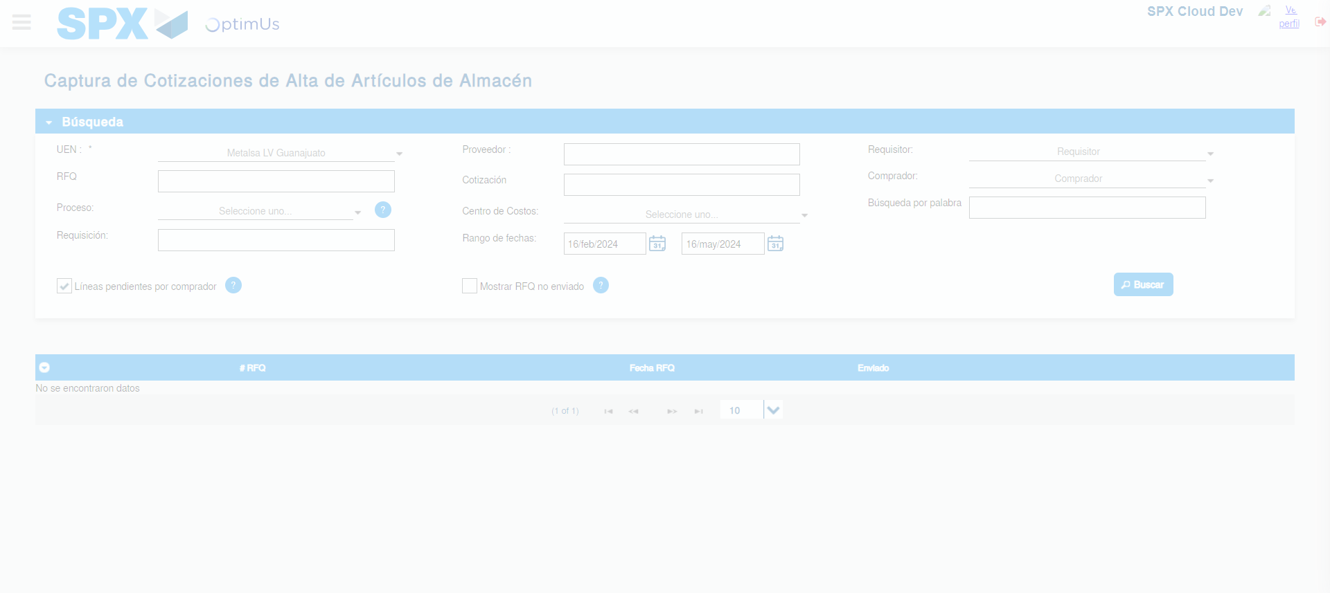Image file-name: QC_Testing-tc002_SPX_Dev5_Validar_Campos_Captura_Cotizaciones-may. 16 2024, 03 25 08 p. m.

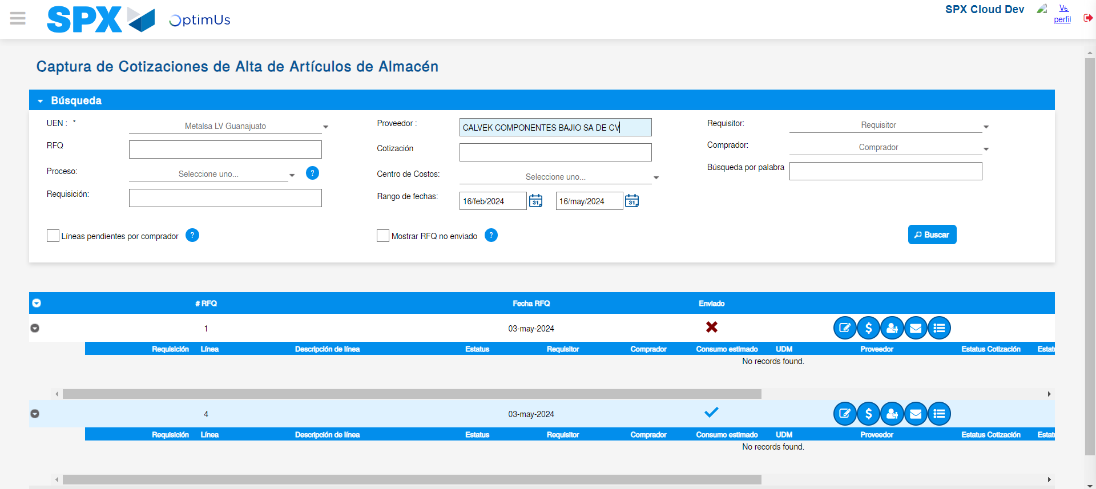Image file-name: QC_Testing-tc002_SPX_Dev5_Validar_Campos_Captura_Cotizaciones-may. 16 2024, 03 25 12 p. m.

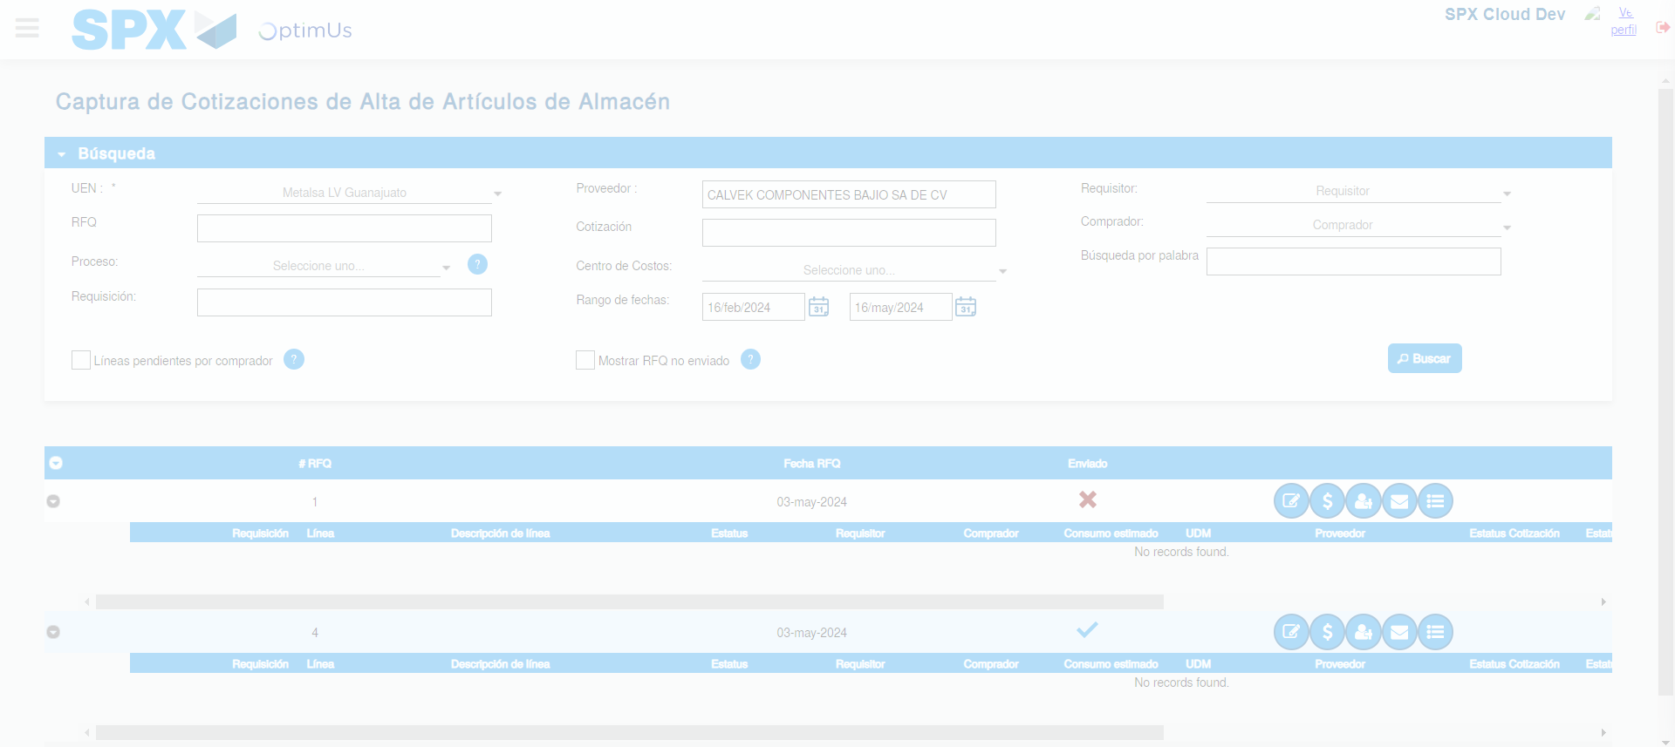Image file-name: QC_Testing-tc002_SPX_Dev5_Validar_Campos_Captura_Cotizaciones-may. 16 2024, 03 25 16 p. m.

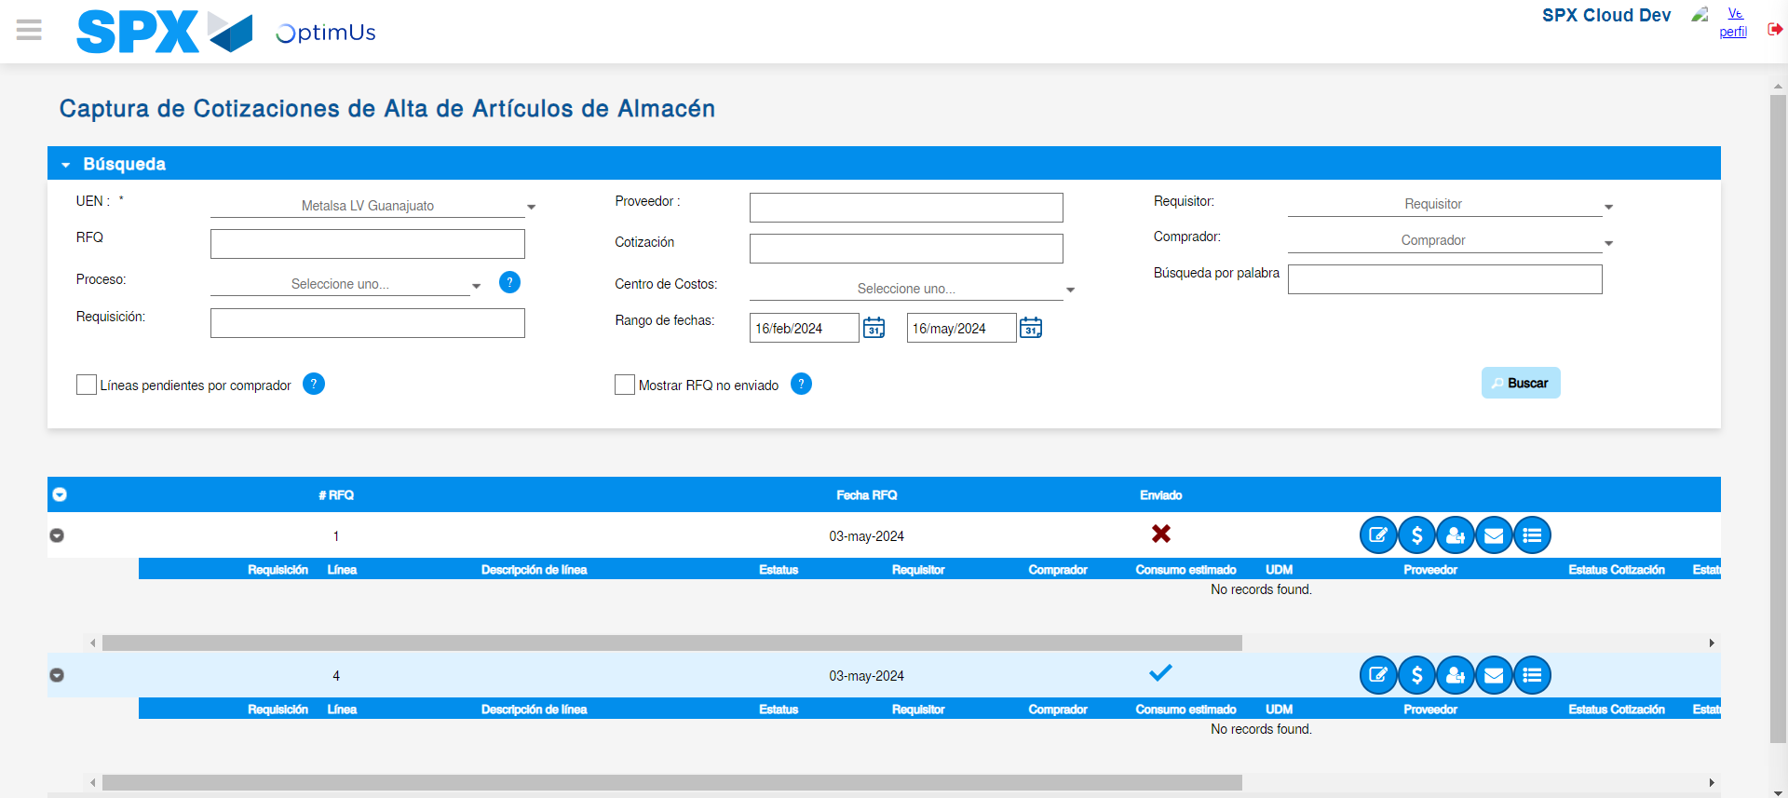Image file-name: QC_Testing-tc002_SPX_Dev5_Validar_Campos_Captura_Cotizaciones-may. 16 2024, 03 25 19 p. m.

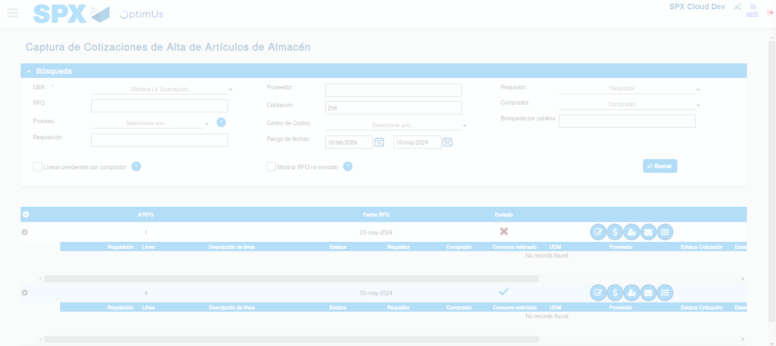Image file-name: QC_Testing-tc002_SPX_Dev5_Validar_Campos_Captura_Cotizaciones-may. 16 2024, 03 25 23 p. m.

Image file-name: QC_Testing-tc002_SPX_Dev5_Validar_Campos_Captura_Cotizaciones-may. 16 2024, 03 25 27 p. m.

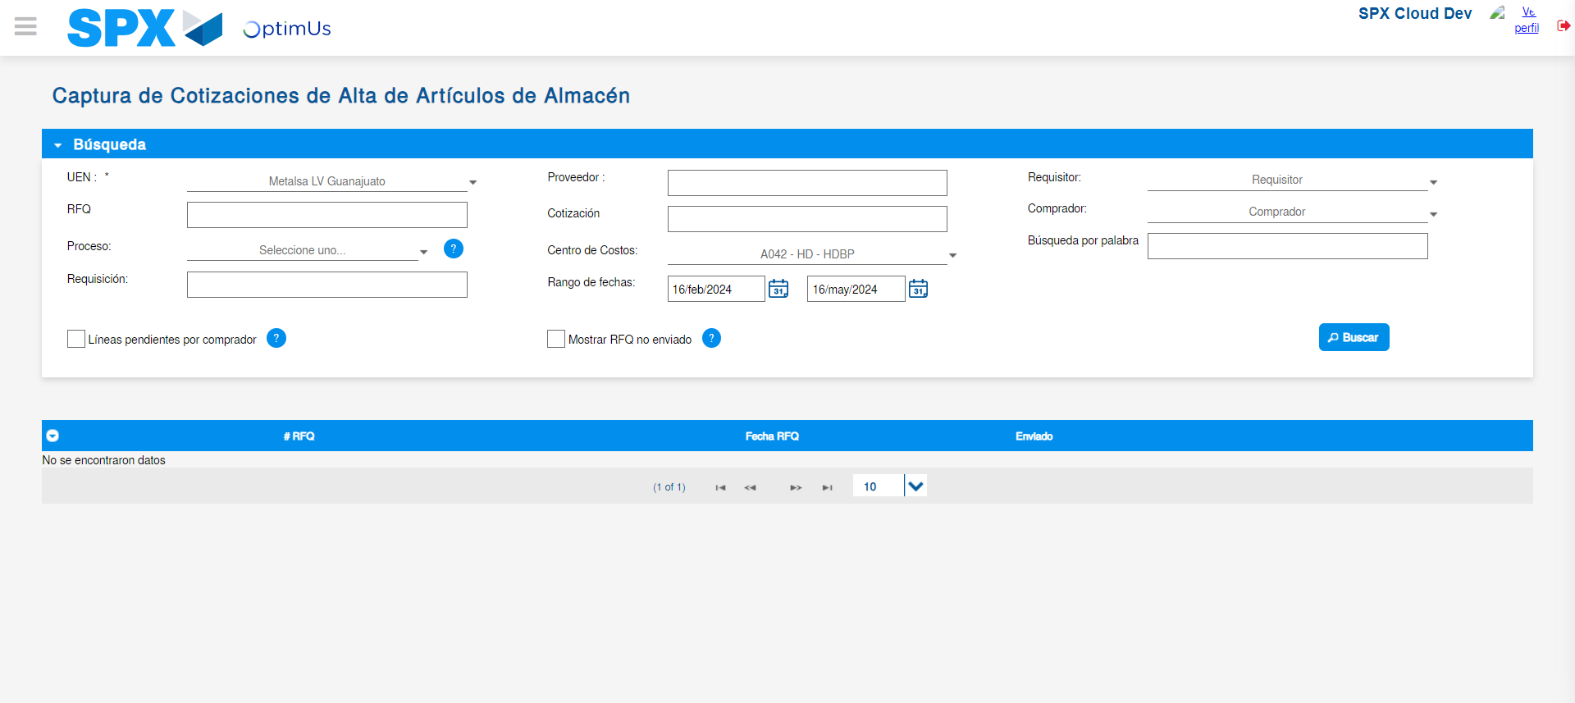Image file-name: QC_Testing-tc002_SPX_Dev5_Validar_Campos_Captura_Cotizaciones-may. 16 2024, 03 25 30 p. m.

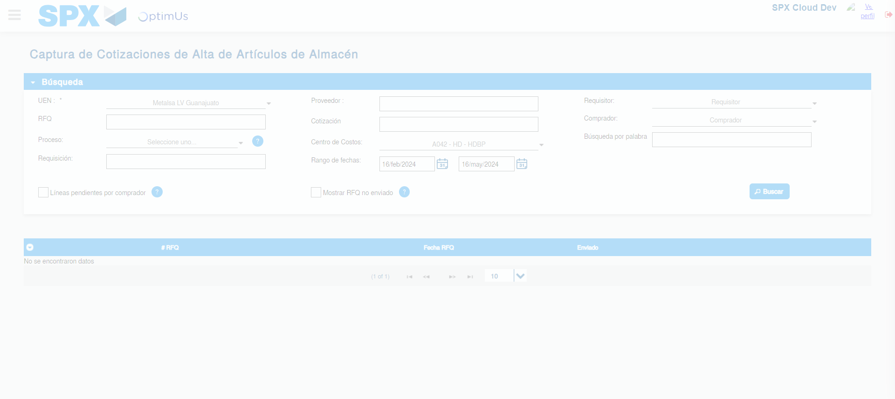Image file-name: QC_Testing-tc002_SPX_Dev5_Validar_Campos_Captura_Cotizaciones-may. 16 2024, 03 25 34 p. m.

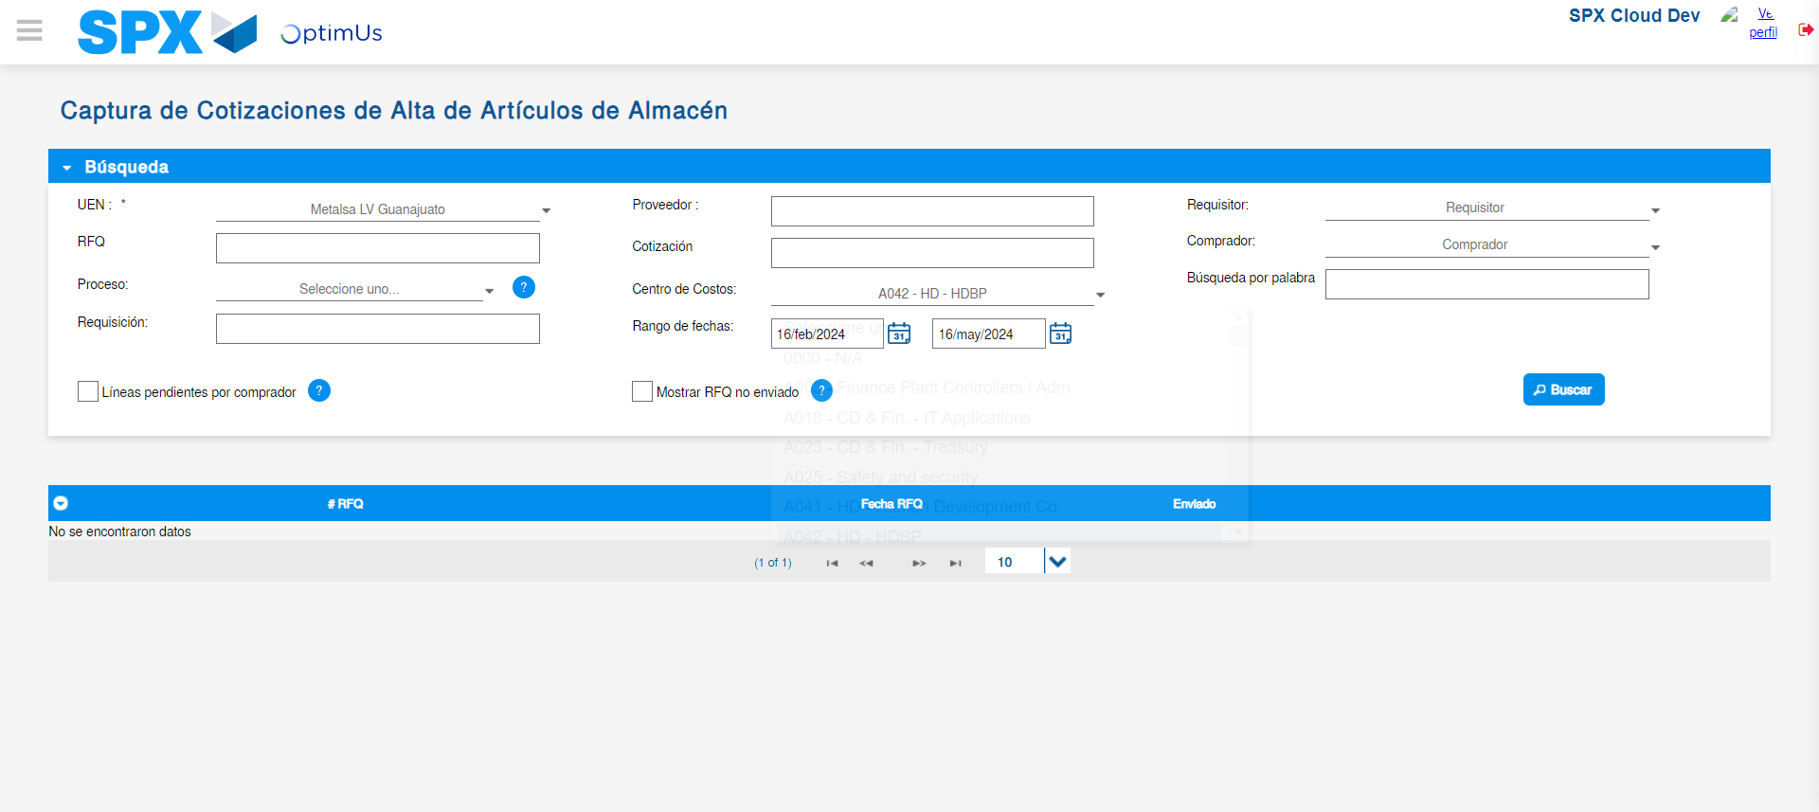Image file-name: QC_Testing-tc002_SPX_Dev5_Validar_Campos_Captura_Cotizaciones-may. 16 2024, 03 25 37 p. m.

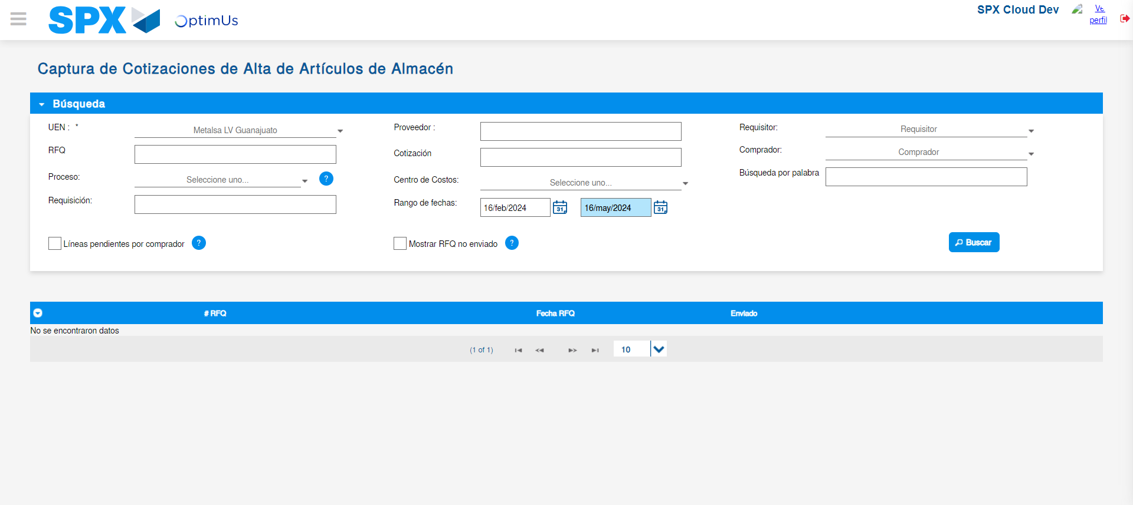Image file-name: QC_Testing-tc002_SPX_Dev5_Validar_Campos_Captura_Cotizaciones-may. 16 2024, 03 25 38 p. m.

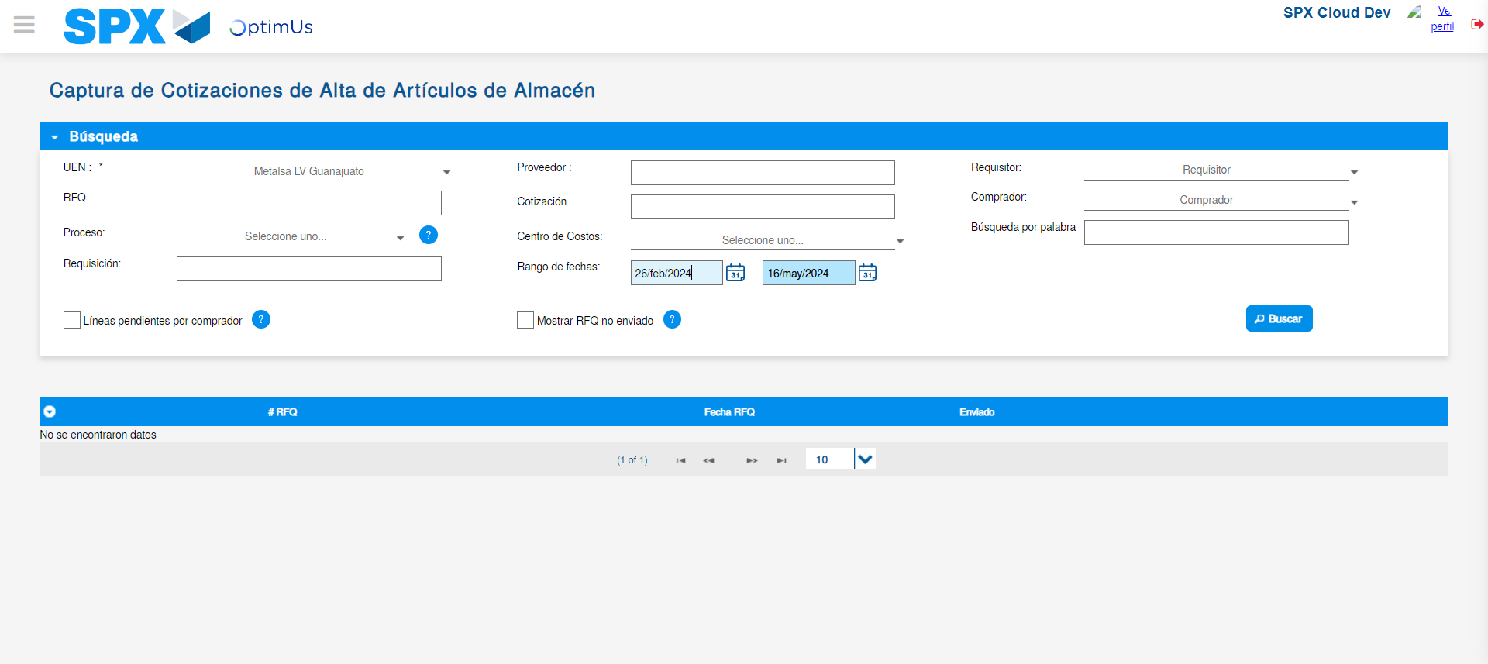Image file-name: QC_Testing-tc002_SPX_Dev5_Validar_Campos_Captura_Cotizaciones-may. 16 2024, 03 25 41 p. m.

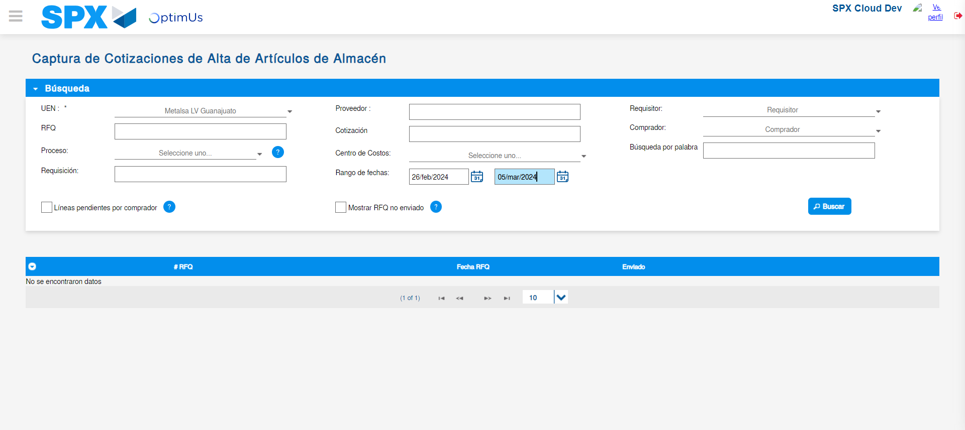Image file-name: QC_Testing-tc002_SPX_Dev5_Validar_Campos_Captura_Cotizaciones-may. 16 2024, 03 25 42 p. m.

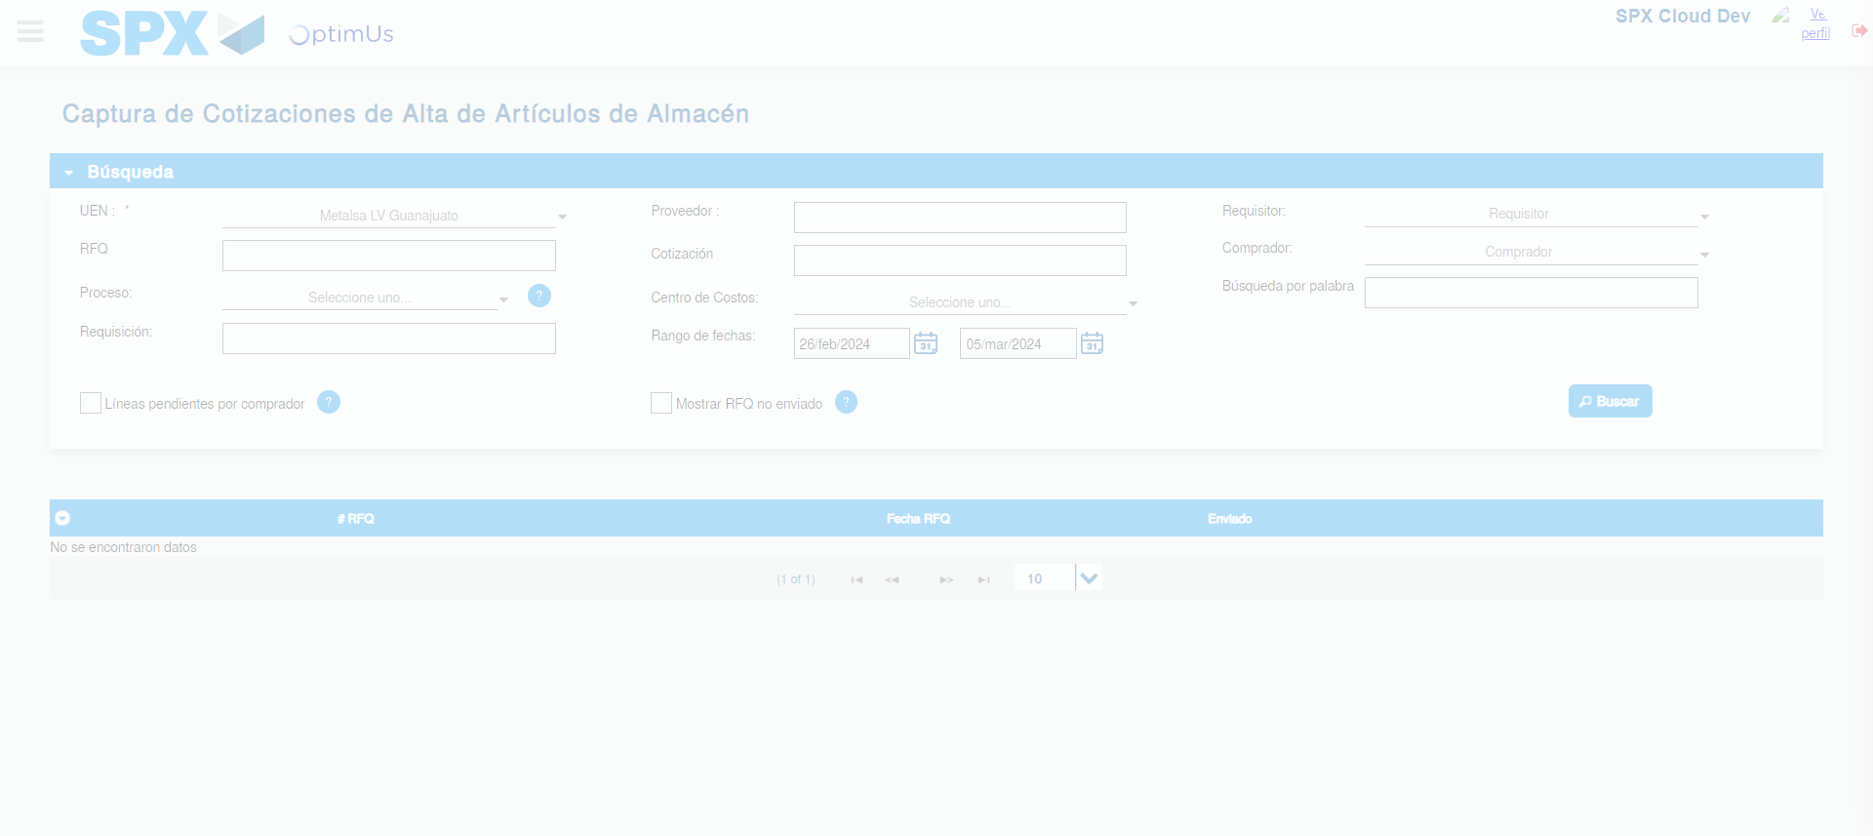Image file-name: QC_Testing-tc002_SPX_Dev5_Validar_Campos_Captura_Cotizaciones-may. 16 2024, 03 25 43 p. m.

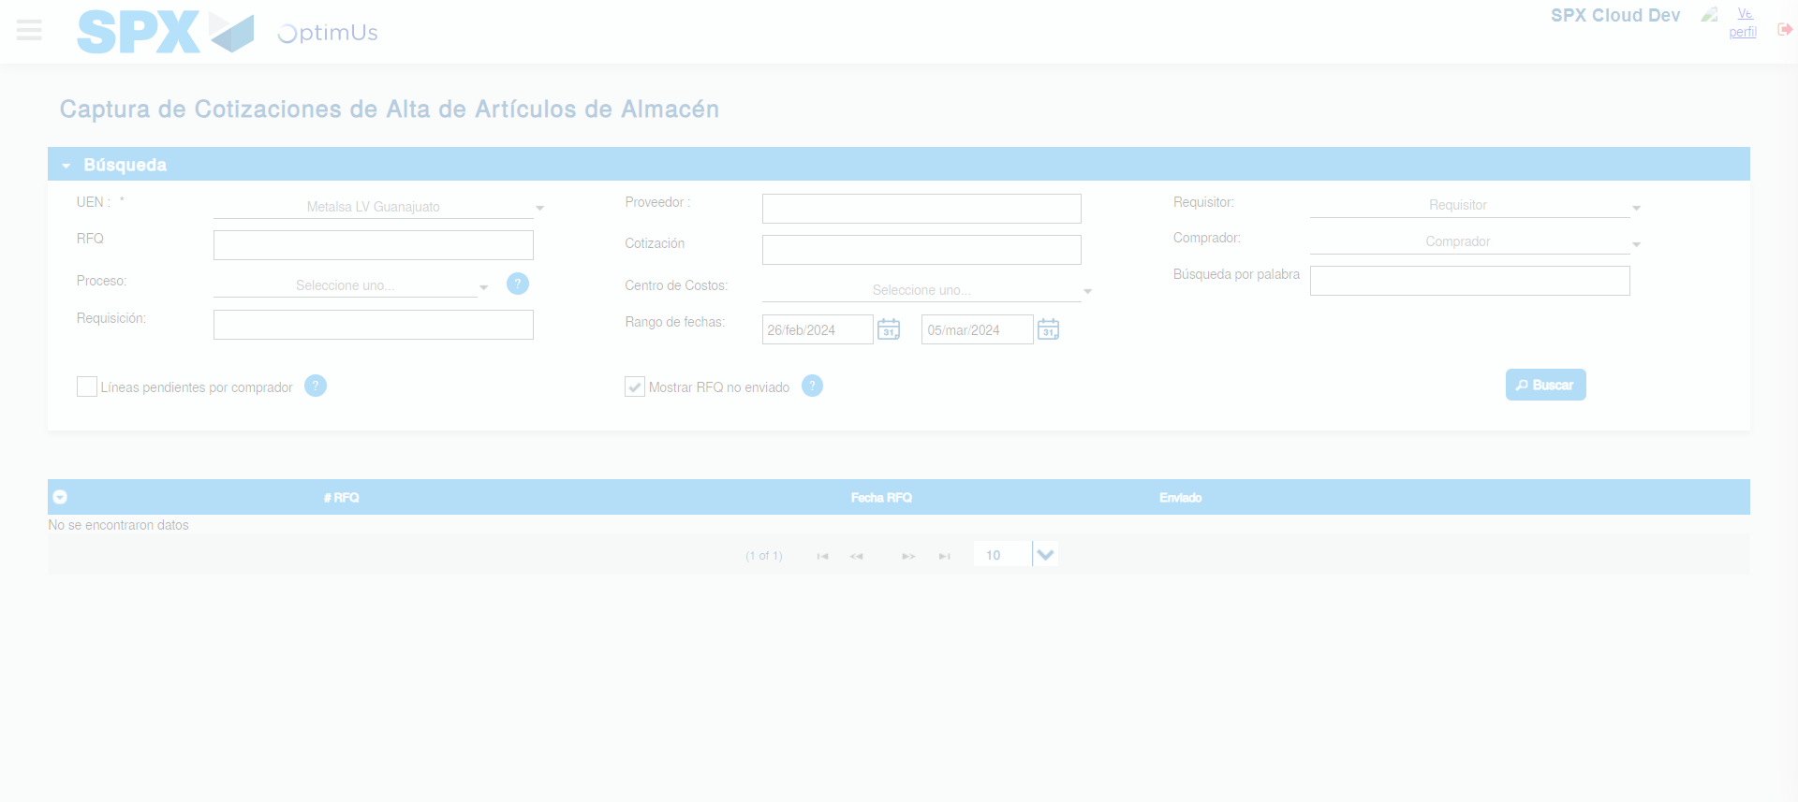Image file-name: QC_Testing-tc002_SPX_Dev5_Validar_Campos_Captura_Cotizaciones-may. 16 2024, 03 25 46 p. m.

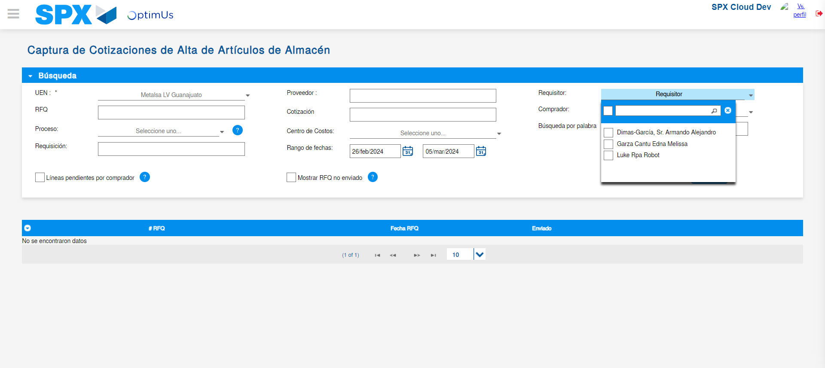Image file-name: QC_Testing-tc002_SPX_Dev5_Validar_Campos_Captura_Cotizaciones-may. 16 2024, 03 25 50 p. m.

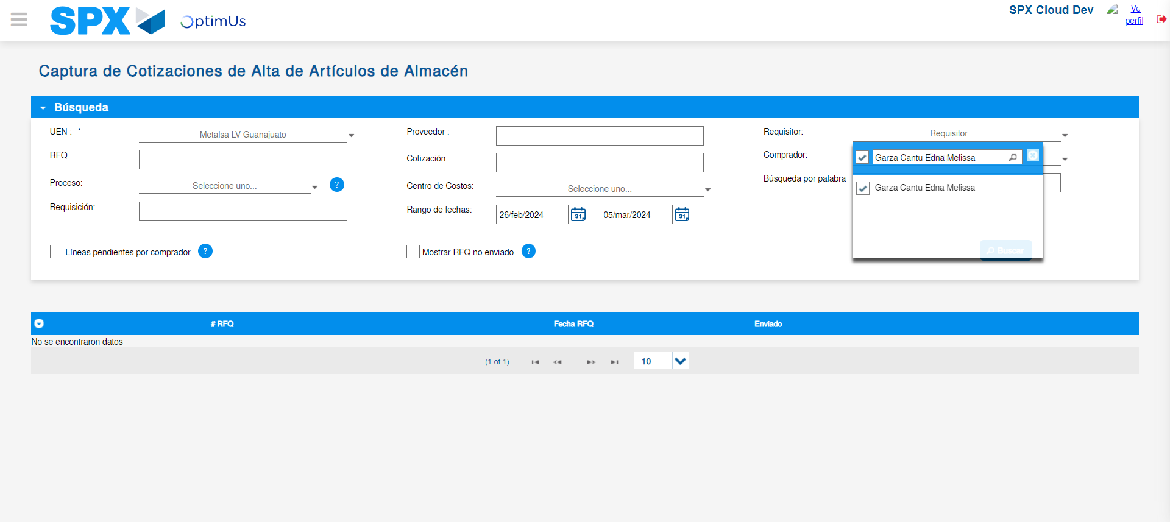Image file-name: QC_Testing-tc002_SPX_Dev5_Validar_Campos_Captura_Cotizaciones-may. 16 2024, 03 25 51 p. m.

Image file-name: QC_Testing-tc002_SPX_Dev5_Validar_Campos_Captura_Cotizaciones-may. 16 2024, 03 25 52 p. m.

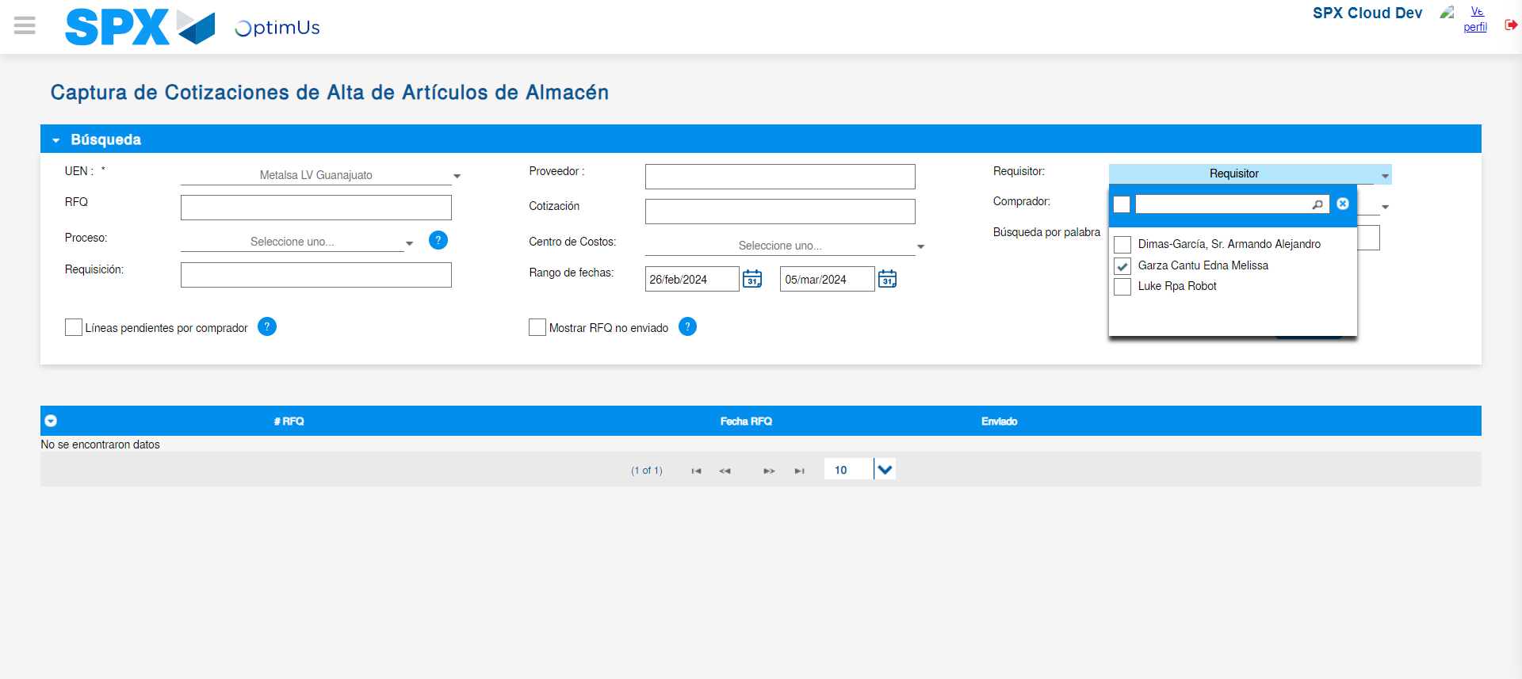Image file-name: QC_Testing-tc002_SPX_Dev5_Validar_Campos_Captura_Cotizaciones-may. 16 2024, 03 25 55 p. m.

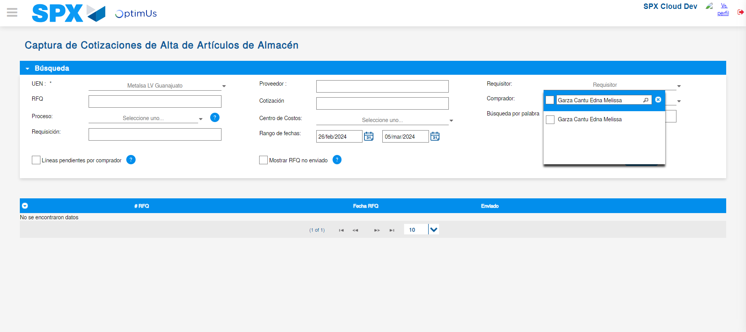Image file-name: QC_Testing-tc002_SPX_Dev5_Validar_Campos_Captura_Cotizaciones-may. 16 2024, 03 25 56 p. m.

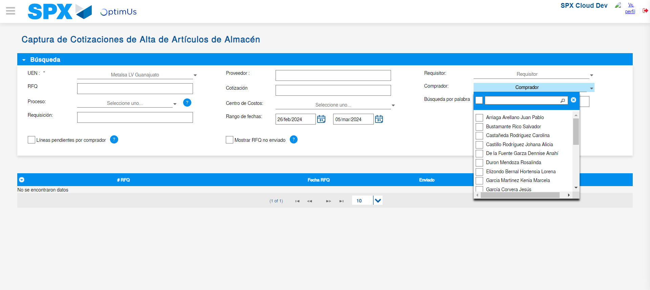Image file-name: QC_Testing-tc002_SPX_Dev5_Validar_Campos_Captura_Cotizaciones-may. 16 2024, 03 25 57 p. m.

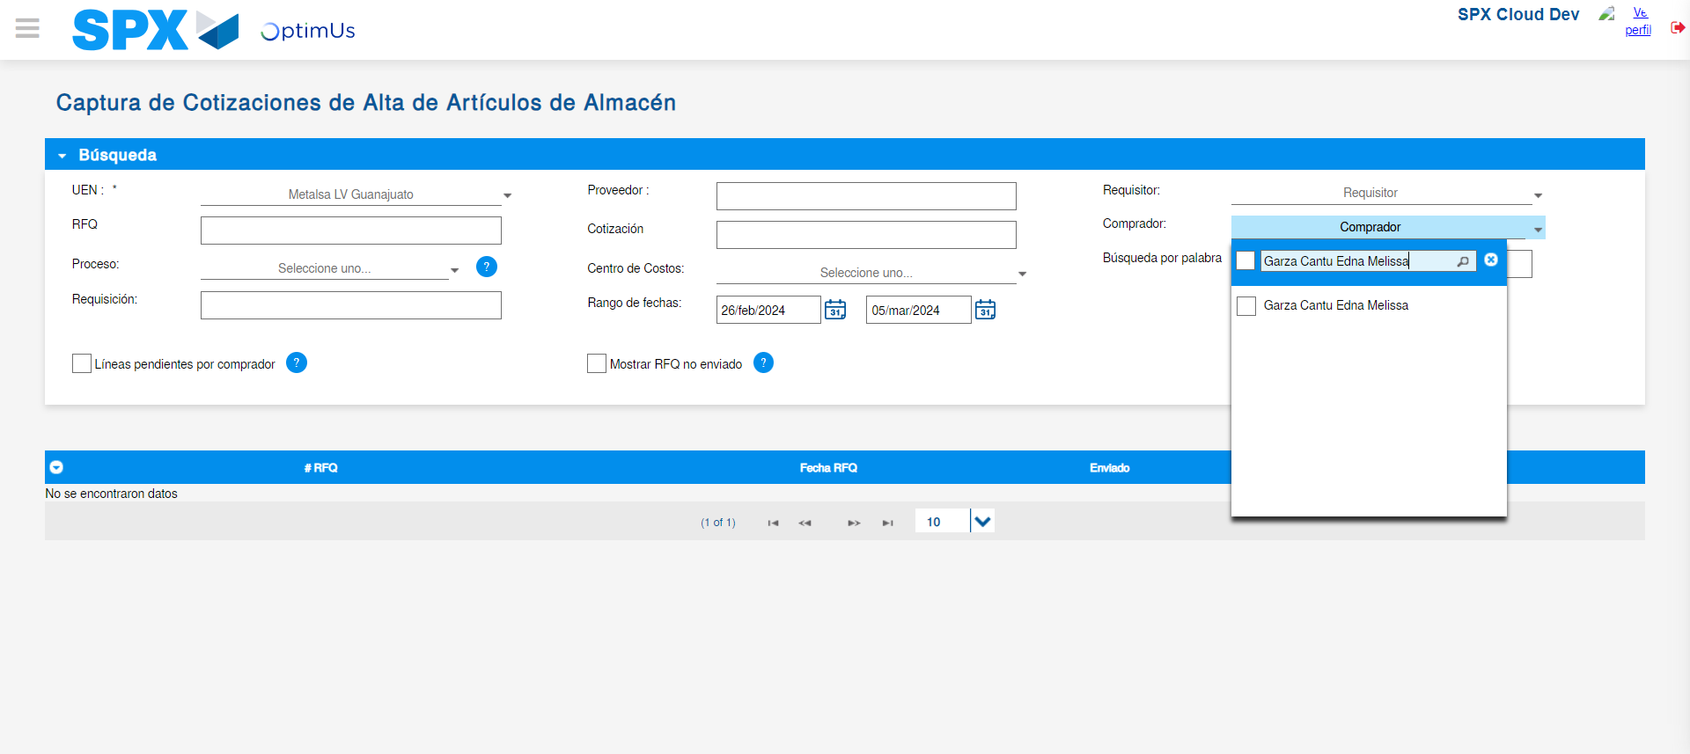Image file-name: QC_Testing-tc002_SPX_Dev5_Validar_Campos_Captura_Cotizaciones-may. 16 2024, 03 25 58 p. m.

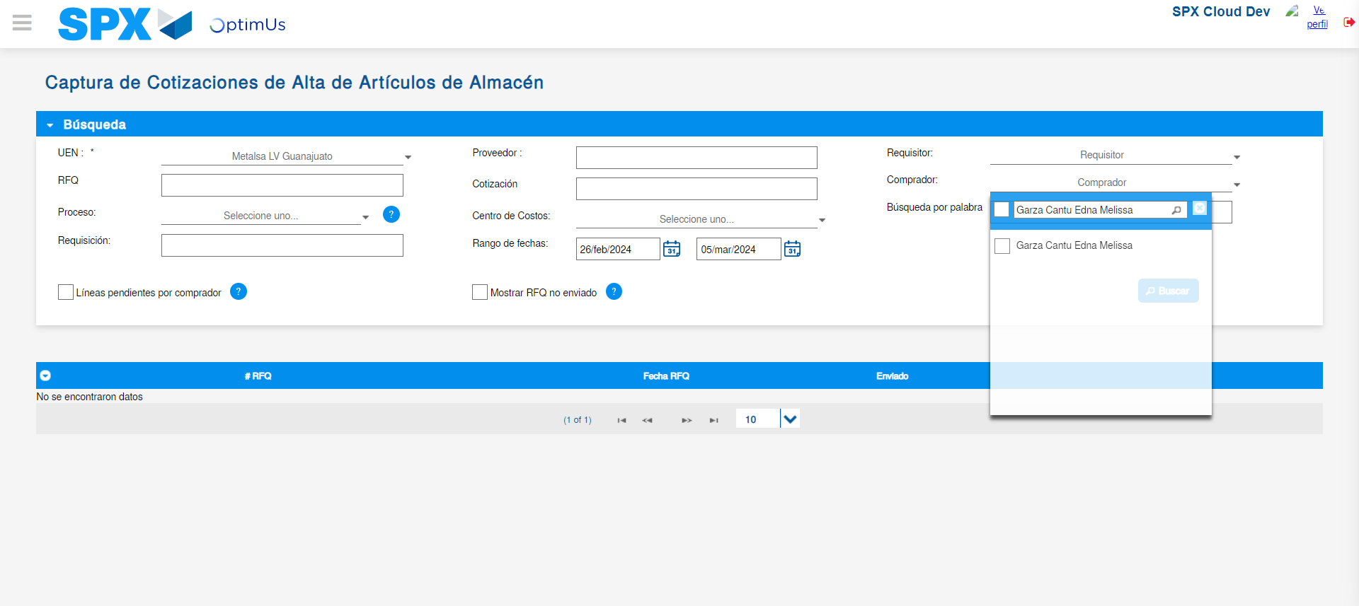Image file-name: QC_Testing-tc002_SPX_Dev5_Validar_Campos_Captura_Cotizaciones-may. 16 2024, 03 26 08 p. m.

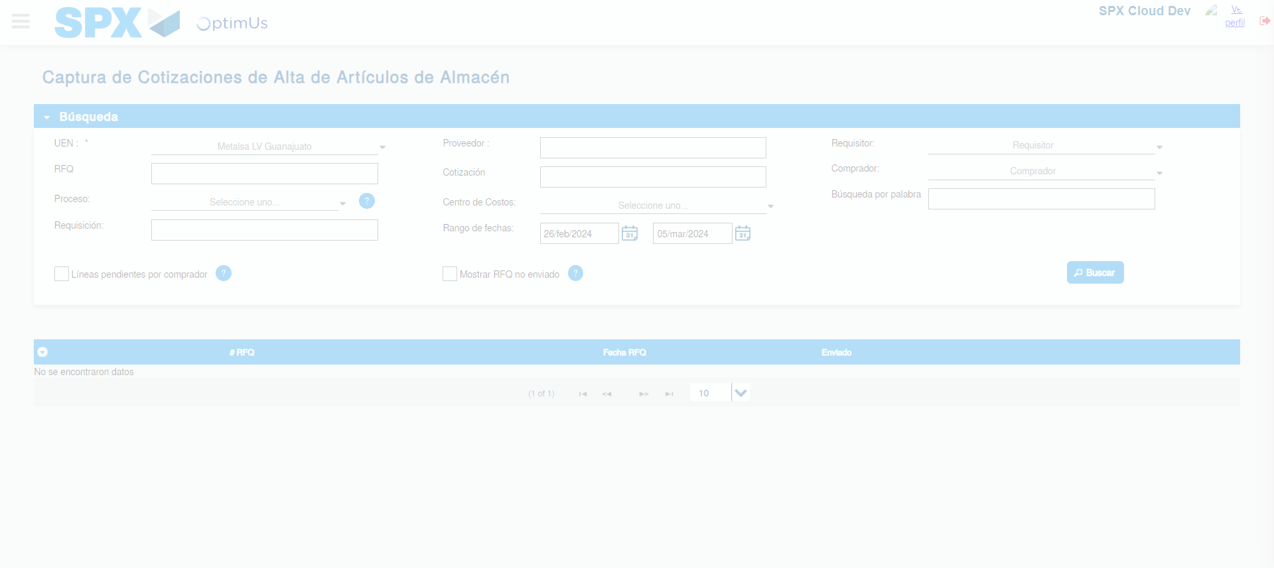Image file-name: QC_Testing-tc002_SPX_Dev5_Validar_Campos_Captura_Cotizaciones-may. 16 2024, 03 26 09 p. m.

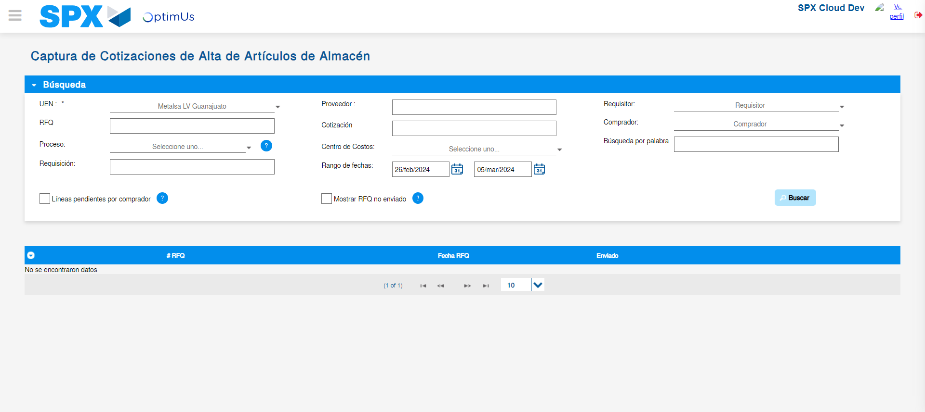Image file-name: QC_Testing-tc002_SPX_Dev5_Validar_Campos_Captura_Cotizaciones-may. 16 2024, 03 26 12 p. m.

